**MERRY’S INFO-TECH & NEW-GEN EDUCARE**

**AECP - PRODUCT DOCUMENT**

Version - 2

11-06-2024

**TABLE OF CONTENTS**

**1. Product Overview**

1.1. Product Description

1.2. Product Vision

**2. Target Audience**

2.1. Primary Audience

2.2. Secondary Audience

**3. Key Features**

**3.1. Material Management**

3.1.1. Description

3.1.2. Benefits

**3.2. Project management**

3.2.1. Description

3.2.2. Benefits

**3.3. Task management**

3.3.1. Description

3.3.2. Benefits

**3.4. Leave management**

3.4.1. Description

3.4.2. Benefits

**3.5. Budget Management**

3.5.1 Description

3.5.2. Benefits

**3.6. Notification system & Email system**

3.6.1. Description

3.6.2. Benefits

**3.7. Monthly report generation**

3.7.1. Description

3.7.2. Benefits

**3.8. Profile Management**

3.8.1. Description

3.8.2. Benefits

**3.9. Daily calendar management**

3.9.1. Description

3.9.2. Benefits

**3.10. Request management**

3.10.1. Description

3.10.2. Benefits

**3.11. Equipment Maintenance**

3.11.1. Description

3.11.2. Benefits

**3.12. Stock Maintenance**

3.12.1. Description

3.12.2. Benefits

**3.13. Wastage maintenance**

3.13.1. Description

3.13.2. Benefits

**3.14. Invoice**

3.14.1. Description

3.14.2. Benefits

**3.15. Client Management**

3.15.1. Description

3.15.2. Benefits

**3.16. Macro Management**

3.16.1. Description

3.16.2. Benefits

**3.17. Suppliers Overview**

3.17.1. Description

3.17.2. Benefits

**3.18. Orders Management**

3.18.1. Description

3.18.2. Benefits

**4. User Interface (UI) Overview**

**5. System Architecture**

5.1. Technology Stack

5.2. Databases

5.3. Integrations

**6. Security Measures**

6.1. Data Encryption

6.2. Authentication

6.3. Authorization

**7. Roadmap**

7.1. Planned Updates

7.2. Enhancements

7.3. New Features

7.4. Estimated Release Dates

**8. Installation and Compatibility**

8.1. System Requirements

8.2. Platform Compatibility

8.3. Installation Instructions

**9. Getting Started**

9.1. Step-by-Step Instructions

**10. Contact Information**

10.1. General Inquiries

**11. Legal Information**

11.1. Disclaimers

11.2. Terms of Service

11.3. Privacy Policy

**12. Version History**

12.1. Version 1.0 (Release Date)

12.2. Key Changes

**13. Conclusion**

13.1. Summary of Key Points

13.2. Value and Benefits

**1. Product Overview**

**1.1. Product Description**

Introducing AECP, a revolutionary solution for the construction industry designed to empower General Managers and streamline operations. AECP facilitates seamless coordination of labour resources, project progress monitoring, and material procurement, with features tailored specifically to the construction sector. It centralizes critical functions, enhancing coordination across various departments and ensuring smooth workflow management. By automating routine tasks and providing comprehensive tracking tools, AECP helps construction companies increase productivity and efficiency. Detailed tracking and efficient resource utilization help stay within budget and reduce unnecessary expenses. With the client panel, stakeholders can stay informed about project developments, fostering better communication and trust. AECP is designed specifically for the construction industry, with features that address the unique challenges faced by construction companies. Its user-friendly interface ensures quick adoption by staff and minimal training time. Suitable for projects of all sizes, AECP is a scalable solution, from small-scale renovations to large infrastructure developments. Transform your construction management with AECP and build a future of success.

**1.2. Product Vision**

Our vision for AECP in the construction industry is to revolutionize project management and operational efficiency. We aim to provide a comprehensive platform that empowers General Managers to oversee every aspect of construction projects seamlessly. AECP will streamline employee management, project tracking, store administration, client management, procurement management and HR functions, optimizing resource utilization and minimizing costs.

Our goal is to simplify complex processes, such as material procurement and labour allocation, to ensure projects stay on track and within budget. By centralizing critical functions within a user-friendly interface, AECP will promote collaboration, transparency, and productivity across construction teams. Ultimately, we envision AECP as the cornerstone for construction project success, driving innovation and excellence in the industry.

**2. Target Audience**

**2.1. Primary Audience**

**1.** **Project Owners/Clients:**

Content focusing on the benefits of the EPC model, such as single-point accountability, streamlined project management, and risk mitigation.

Case studies showcasing successful EPC projects, highlighting cost savings, timeline adherence, and quality outcomes.

**2.** **Engineering Professionals:**

Technical articles or blog posts discussing innovative engineering solutions and best practices in EPC project design and execution.

Webinars or video tutorials on specialized engineering topics relevant to EPC projects, such as structural analysis, process optimization, or environmental compliance**.**

**3. Procurement and Supply Chain Managers:**

Content highlighting strategies for effective procurement and supplier management in EPC projects, including supplier evaluation criteria, negotiation tactics, and risk mitigation strategies.

Case studies demonstrating successful procurement practices that contributed to project cost savings, quality improvements, or schedule acceleration.

Guides or checklists for optimizing the procurement process in EPC projects, covering aspects like vendor selection, contract management, and supply chain logistics.

**4. Construction and Project Management Professionals:**

Content focusing on construction management best practices, project scheduling techniques, and quality control measures in EPC projects.

Webinars or podcasts featuring industry experts discussing project management challenges and solutions specific to EPC projects.

**2.2. Secondary Audience**

**1.** **Civilian Contractors and Engineers:**

The second target audience may consist of civilian contractors, engineers, and professionals in the construction industry. These individuals may be interested in collaborating with the military on various projects, providing their expertise, and potentially participating in the AECP to support military infrastructure and construction initiatives.

**2. Government Agencies and Departments:**

Government agencies and departments involved in infrastructure development and national security may also be a target audience for the AECP. These entities may collaborate with the military on various projects and initiatives, making them potential stakeholders in the program.

**3. Industry Associations and Organizations:**

Associations and organizations representing the engineering, construction, and defence industries could also be considered a target audience for the AECP. These groups may provide support, resources, and networking opportunities for military personnel participating in the program.

**3. Key Features**

**3.1. Material Management**

AECP’s Material management is essentially the organization of all the activities involved in getting the right materials, in the right quantities, to the right place, at the right time. It's a crucial part of the supply chain for any business that deals with physical products.

**3.1.1. Description**

Material management is the backbone of any operation that relies on physical resources. It's a strategic approach that ensures a steady flow of materials, from planning and purchasing to storage and handling. The process starts with forecasting what materials will be needed and when (planning). This information is then used to source materials from suppliers, negotiate prices, and manage purchase orders (purchasing). Once materials arrive, inventory control comes into play, which involves tracking stock levels and implementing strategies to minimize waste and stock outs. Finally, proper storage practices and efficient handling procedures ensure materials are protected from damage and readily accessible when production or operations need them.

**3.1.2. Benefits**

**1. Cost Savings:**

By optimizing inventory levels and streamlining purchasing processes, material management reduces unnecessary spending and avoids waste..

**2. Improved Efficiency:**

Having the right materials on hand when needed keeps production or operations running smoothly and avoids delays.

**3.** **Enhanced Customer Satisfaction:**

When material management is effective, businesses are better equipped to meet customer demands and delivery deadlines.

**4. Better Decision-Making:**

Material management practices involve data collection and analysis, which provides valuable insights to inform better decision-making about procurement and inventory management.

**3.2. Project management**

AECP’s Project Management feature empowers organizations to efficiently oversee and manage projects from inception to completion.

**3.2.1. Description**

The project management framework for AECP, EPC projects encompasses various phases, including project initiation, planning, execution, monitoring and control, and project closure. During the initiation phase, project objectives, scope, and stakeholders are identified, and initial feasibility assessments are conducted. In the planning phase, detailed project plans, schedules, budgets, and resource allocations are developed to guide project execution.

**3.2.2. Benefits**

**1. Effective Resource Management:**

Project management facilitates efficient allocation and utilization of resources, including personnel, equipment, and materials, optimizing project outcomes and minimizing waste.

**2. Timely Delivery:**

By establishing clear project plans and schedules, project management helps ensure timely completion of EPC projects, enabling the clients to meet operational requirements and strategic objectives.

**3.** **Cost Control:**

Rigorous cost management practices, including budget planning, monitoring, and cost variance analysis, help prevent cost overruns and ensure that EPC projects are delivered within budget constraints.

**4. Quality Assurance:**

Project management processes incorporate quality control measures to verify compliance with design specifications and regulatory requirements, ensuring that constructed infrastructure meets high-quality standards.

**5. Risk Mitigation:**

Through proactive risk identification, assessment, and mitigation strategies, project management minimizes the impact of potential risks and uncertainties on project outcomes, enhancing project resilience and success.

**6. Continuous Improvement:**

Project management practices facilitate ongoing evaluation and optimization of project processes, enabling continuous improvement and fostering a culture of learning and innovation within the AECP.

**3.3. Task management**

AECP’s Task Management feature simplifies task coordination and delegation within organizations, enhancing productivity and ensuring that work is organized and tracked effectively.

**3.3.1. Description**

AECP Task Management feature provides organizations with a centralized platform for efficient task coordination, assignment, and tracking. It simplifies the process of organizing and prioritizing tasks across projects and teams, promoting accountability and ensuring that work is completed on time. With real-time task tracking, collaboration tools, and customizable task management options, AECP empowers organizations to streamline their task workflows and enhance overall productivity.

**3.3.2. Benefits**

**1. Improved Project Efficiency:**

Effective project management streamlines project processes, reduces inefficiencies, and optimizes resource utilization, resulting in improved project efficiency and productivity.

**2. Enhanced Risk Mitigation:**

Robust risk management practices help identify and mitigate potential risks, reducing

the likelihood of costly disruptions and delays during project execution.

**3. Cost Control:**

Rigorous cost management enables better control over project expenditures, minimizing cost overruns and ensuring that projects are delivered within budget constraints.

**4** .**Timely Delivery:**

Clear project timelines and proactive schedule management help ensure that projects are completed on time, enabling timely delivery of critical infrastructure assets.

**5**. **Quality Assurance:**

Comprehensive quality control measures ensure that construction activities meet established standards and specifications, resulting in high-quality infrastructure that meets user requirements.

**3.4. Leave management**

AECP’s Leave Management feature simplifies the process of tracking, applying for, and managing employee leaves.

**3.4.1. Description**

The Leave Management system is a specialized module within the engineering procurement and construction (EPC) project management. This system is designed to efficiently manage and coordinate the leave requests and schedules of site managers and project managers involved in EPC projects.

At its core, this system provides a centralized platform where site managers and project managers can submit leave requests, view their leave balances, and coordinate their schedules with project timelines and staffing requirements. The system allows managers to specify the duration and reason for their leave, as well as any necessary backup arrangements to ensure project continuity during their absence.

**3.4.2. Benefits**

**1** **Efficient Resource Planning:**

The leave management system enables site managers and project managers to effectively plan their absences in alignment with project timelines and staffing needs, ensuring optimal resource utilization and project continuity.

**2. Streamlined Leave Requests:**

By providing a centralized platform for leave requests, the system simplifies the process of submitting, reviewing, and approving leave requests, reducing administrative burden and enhancing efficiency.

**3. Improved Visibility and Transparency:**

Real-time access to leave balances, schedules, and staffing arrangements enhances visibility and transparency across the project team, enabling better coordination and decision-making.

**4. Enhanced Compliance:**

Automated approval workflows and compliance checks help ensure that leave requests adhere to organizational policies and project requirements, reducing the risk of scheduling conflicts or disruptions.

**5. Mitigation of Operational Risks:**

By facilitating backup arrangements and contingency planning for manager absences, the system helps mitigate operational risks and minimize the impact of unexpected disruptions on project performance.

**6. Employee Satisfaction:**

Streamlined leave management processes contribute to a positive work environment by providing employees with greater flexibility, clarity, and control over their schedules, leading to increased job satisfaction and morale.

**7.** **Data-Driven Decision Making:**

Reporting and analytics features within the leave management system provide valuable insights into leave trends, patterns, and resource utilization, enabling data-driven decision-making and continuous improvement in workforce management practices.

**3.5. Budget Management**

AECP’s Budget management is the process of creating a plan for your income and expenses. It's like a roadmap that helps you track your financial situation and make informed decisions about your money.

**3.5.1. Description**

Financial security is like building a house - you need a solid foundation. Budget management is that foundation. It's the process of creating a plan for your income and expenses, like a blueprint for your finances. You define your goals, track your money coming in and going out, and regularly review your progress. This lets you identify areas to cut back or boost your income, all to achieve your financial dreams, whether it's saving for a house or simply reducing stress. By taking control of your money with a budget, you build a secure financial future and gain peace of mind.

**3.5.2. Benefits**

**1. Reduced Financial Stress:**

Knowing where your money goes and having a plan can significantly reduce financial anxiety.

**2. Achieving Financial Goals:**

A budget helps you prioritize your spending and allocate funds towards your financial objectives.

**3. Improved Decision-Making:**

By understanding your income and expenses, you can make informed choices about purchases, debt management, and saving strategies.4. Monthly Report Generation

**4. Peace of Mind:**

Having a financial safety net built through budgeting provides a sense of security and control over your money.

**3.6. Notification system & Email system**

AECP's Notification System & Email System ensure timely communication and updates, with customizable alerts, instant notifications, and email integration for seamless collaboration and informed decision-making.

**3.6.1. Description**

AECP’s Notification System and Email System work harmoniously to facilitate efficient communication and keep all stakeholders informed within your organization. These features deliver a comprehensive notification experience, ensuring that task updates, leave requests, and chat notifications seamlessly reach users both within the AECP platform and via email. This dual notification approach enhances collaboration, project tracking, and timely decision-making across the organization.

**3.6.2. Benefits**

**1. Real-Time Communication**

Instant notifications keep everyone informed and enable prompt responses, fostering better collaboration and teamwork.

**2. Multi-Channel Reach**

Benefit from both in-app notifications and email integration, ensuring that important messages reach users, whether they are actively using AECP or not.

**3. Enhanced Collaboration**

Improve collaboration and teamwork with instant notifications, fostering quicker responses and better project coordination.

**4. Task Management**

Set task reminders and due date notifications to stay organized, meet project deadlines, and reduce the risk of missed tasks.

**3.7. Monthly report generation**

The Monthly Report Generator in AECP empowers organizations to transform raw data into meaningful insights, enabling informed decision-making, enhancing productivity, and contributing to overall success.

**3.7.1. Description**

The Monthly Report Generator is a tool developed specifically for the Engineering, Procurement, and Construction (EPC) .It is designed to automate the generation of detailed monthly reports that provide comprehensive insights into the progress, performance, and status of ongoing construction projects. This tool aggregates data from various sources, including project management systems, financial records, and progress reports, to create standardized reports that facilitate decision-making and communication among stakeholders.

The Monthly Report Generator utilizes advanced data analytics and visualization techniques to present key metrics, trends, and milestones in a clear and concise format. It allows project managers, engineers, and other stakeholders to track project progress, identify areas of concern, and make informed decisions to ensure the successful completion of EPC projects within established timelines and budgets.

**3.7.2. Benefits**

**1. Time Efficiency**

Automate the report generation process, saving valuable time that can be redirected toward more strategic tasks and decision-making.

**2. Data-Driven Insights**

Leverage comprehensive monthly reports to gain data-driven insights into employee performance, project progress, and organizational productivity.

**3. Improved Decision-Making**

Use visual data representations to make informed decisions, identify trends, and set priorities effectively.

**4. Scheduled Reports**

Schedule automated report delivery to relevant stakeholders, ensuring that critical information is shared promptly without manual effort.

**3.8. Profile Management**

AECP's Profile Management feature empowers employees to manage their profiles effectively, ensuring that their information remains accurate and accessible, ultimately fostering a more connected and informed workforce.

**3.8.1. Description**

Engineering, Procurement, and Construction (EPC) projects refers to the systematic management of personnel profiles. This comprehensive system facilitates the organization, tracking, and management of critical information.

**3.8.2. Benefits**

**1. Data Accuracy**

Ensure that employee profiles are accurate and up-to-date, promoting error-free communication and reducing administrative discrepancies.

**2. Personalization**

Add a profile picture to personalize your account, making it easier for colleagues to recognize and connect with you within the organization.

**3. Efficient Password Management**

Easily change passwords within your profile settings, enhancing account security and user control.

**3.9. Daily calendar management**

AECP's Daily Calendar Management feature creates a sense of connection with your employee celebrations, offers personalized greetings, and provides indispensable support to Project Managers with project due date alerts.

**3.9.1. Description**

The daily calendar management process begins with the identification of key project activities and deadlines. Project managers and team members collaborate to prioritize tasks and allocate resources based on project requirements and constraints. Additionally, employees' birthdays and work anniversaries are noted to foster a positive work environment and recognize individual milestones. Using digital calendar tools or project management software, daily schedules are created, updated, and shared with relevant stakeholders to provide visibility into upcoming activities, responsibilities, and important personal dates.

**3.9.2. Benefits**

**1. Employee Celebrations**

Stay connected and foster camaraderie by receiving notifications for employees' birthdays and work anniversaries, adding a personal touch to your workday.

**2. Time-Responsive Greetings**

Experience a personalized touch with dynamic greetings that adjust based on the time of day, welcoming you with a warm "Good morning," "Good afternoon," or "Good evening."

**3. Project Due Date Alerts**

For Project Managers, the calendar becomes a vigilant ally. It displays project due dates prominently, providing proactive reminders as projects approach their deadlines, facilitating efficient project management.

**3.10. Request management**

AECP's Request management is the systematic approach to handling all the service requests submitted within an organization. It ensures these requests are dealt with efficiently, transparently, and consistently.

**3.10.1. Description**

Material requests are all about getting the physical things you need, like raw materials, office supplies, or equipment. It's like making a shopping list for your projects or day-to-day tasks. You define what you need, when you need it, and the system helps ensure it gets delivered to the right place at the right time.

Resource requests, on the other hand, focus on the people and their expertise. Imagine you need a programmer to fix a software bug or a graphic designer to create a presentation. A resource request system helps connect you with the right person who has the specific skills and availability to fulfill your needs. This ensures your projects are staffed appropriately and everyone has the support they need to be productive. Both material and resource requests, when managed effectively, keep your projects on track and your team operating at peak efficiency.

**3.10.2. Benefits**

**1. Increased Efficiency:**

Streamlined workflows and clear processes lead to faster resolution times and less wasted time.

**2. Improved Resource Allocation:**

By prioritizing requests, you can ensure your team focuses on the most critical tasks first.

**3. Enhanced Visibility:**

Request management systems provide valuable data on service trends and resource utilization, allowing for better decision-making.

**4. Boosted Customer (or Employee) Satisfaction:**

Clear communication and timely resolution of requests lead to happier customers or employees.

**3.11. Equipment Maintenance**

AECP's Equipment maintenance is the practice of keeping your equipment in top shape through a variety of tasks. It's like taking your car in for regular tune-ups and oil changes, but applied to all the machinery, tools, and devices that keep your operation running smoothly.

**3.11.1. Description**

Equipment maintenance is the practice of ensuring your machinery, tools, and devices are in top shape. This involves a three-pronged approach: preventive maintenance, where you proactively inspect, clean, lubricate, and make minor fixes to catch small problems before they become big. Corrective maintenance tackles issues after they arise, focusing on repairs or replacements to get things back up and running. Predictive maintenance takes things a step further, using data and smarts to anticipate potential equipment failures before they disrupt your workflow. By prioritizing maintenance, you reap a bounty of benefits. You'll experience less downtime, keeping projects on track. Your equipment will last longer, saving you money on replacements down the road. Safety is enhanced as well-maintained equipment is less prone to malfunctions and accidents.

**3.11.2. Benefits**

**1. Reduced Downtime:**

Regular maintenance helps prevent unexpected equipment failures, minimizing disruptions to your operations and keeping your projects on schedule.

**2. Extended Equipment Lifespan:**

Proper care helps equipment last longer, saving you money on replacements in the long run.

**3. Improved Safety:**

Well-maintained equipment is less likely to malfunction and cause accidents, creating a safer work environment.

**4. Enhanced Efficiency:**

Equipment that runs smoothly operates more efficiently, potentially leading to increased productivity and cost savings.

**3.12. Stock Maintenance**

AECP's Stock maintenance refers to the process of managing and controlling the inventory or stock of goods within a business or organization. It involves monitoring the quantity, location, and condition of items in stock, as well as replenishing inventory as needed to meet demand while minimizing excess or obsolete stock.

**3.12.1. Description**

Stock maintenance is the systematic process of overseeing and managing the inventory or stock of goods within a business or organization. It encompasses a range of activities aimed at ensuring the availability, accuracy, and optimal utilization of stock. This includes tasks such as receiving incoming goods, storing them appropriately in designated locations, regularly monitoring inventory levels, and replenishing stock as needed to meet demand. Additionally, stock maintenance involves keeping detailed records of stock movements, including purchases, sales, returns, and adjustments, to maintain accurate inventory data. Whether conducted manually through spread sheets or paper-based systems or automated using specialized software, effective stock maintenance practices play a crucial role in optimizing inventory management.

**3.12.2. Benefits**

**1. Improved Inventory Accuracy:**

By regularly updating stock levels and tracking movements, businesses can ensure accurate inventory records, reducing the risk of stock outs or excess stock.

**2. Enhanced Efficiency:**

Efficient stock maintenance processes streamline operations, enabling faster order processing, reduced handling times, and improved overall productivity.

**3. Cost Savings:**

Proper stock maintenance helps businesses optimize inventory levels, reducing holding costs associated with excess stock and minimizing the risk of stock obsolescence.

**4. Better Customer Service:**

Maintaining adequate stock levels ensure that businesses can fulfil customer orders promptly, leading to higher customer satisfaction and retention.

**5. Data-Driven Decision Making:**

Stock maintenance systems provide valuable insights into inventory trends, demand patterns, and stock performance, empowering businesses to make informed decisions about purchasing, pricing, and stocking strategies.

**6. Regulatory Compliance:**

Proper stock maintenance practices ensure compliance with regulatory requirements related to inventory management, such as accurate record-keeping and inventory valuation.

**3.13. Wastage Maintenance**

AECP's Wastage maintenance involves the systematic management and reduction of wastage within a business or organization. This process aims to identify, analyse, and mitigate various forms of waste, including material, energy, time, and resources, throughout the operational workflow. The primary goal is to minimize wastage and optimize efficiency across all aspects of the business.

**3.13.1. Description**

Wastage maintenance is a systematic approach to managing and minimizing various forms of waste within an organization's operations. It involves the continuous assessment, analysis, and improvement of processes to identify inefficiencies and reduce wastage of resources such as materials, energy, time, and money. This process aims to optimize resource utilization, streamline workflows, and mitigate environmental impact by implementing strategies to prevent, reduce, or eliminate waste at every stage of production, distribution, and consumption.

**3.13.2. Benefits**

**1. Cost Reduction:**

By minimizing wastage, businesses can reduce unnecessary expenditures on materials, energy, labour, and other resources, leading to significant cost savings over time.

**2. Improved Efficiency:**

Wastage maintenance helps streamline processes, eliminate inefficiencies, and optimize resource utilization, leading to improved productivity and operational efficiency.

**3. Enhanced Sustainability:**

Reducing wastage contributes to environmental sustainability by conserving natural resources, reducing pollution and emissions, and minimizing the ecological footprint of operations.

**4. Higher Quality Products and Services:**

By eliminating defects and errors that contribute to wastage, businesses can improve the quality and consistency of their products and services, leading to greater customer satisfaction and loyalty.

**5. Compliance and Reputation:**

Effective wastage maintenance demonstrates a commitment to responsible business practices and compliance with regulatory requirements, enhancing the organization's reputation and credibility among stakeholders.

**3.14. Invoice Generation**

An invoice is a commercial document issued by a seller to a buyer, indicating the products, quantities, and agreed-upon prices for products or services the seller has provided to the buyer. It serves as a formal request for payment and includes essential details such as the invoice number, date of issue, seller's and buyer's contact information, itemized list of goods or services, unit prices, total amounts due, payment terms, and any applicable taxes or discounts.

**3.14.1. Description**

Invoice is a crucial document in business transactions that provides a detailed record of goods or services provided, along with their respective costs, to a customer. It serves as a formal request for payment from the customer and acts as proof of the transaction between the seller and the buyer. Invoices typically include important details such as the invoice number, date, seller's and buyer's information, description of the goods or services, quantities, prices, taxes, and payment terms.

**3.14.2. Benefits**

**1. Documentation and Record Keeping:**

Invoices provide a clear and organized record of transactions, making it easier to track sales, monitor payments, and maintain financial records.

**2. Legal Protection:**

Invoices serve as legally binding documents that outline the terms of the sale and provide evidence of the agreed-upon transaction in case of disputes or legal issues.

**3. Payment Tracking:**

Invoices help businesses keep track of outstanding payments, overdue invoices, and payment histories, facilitating better cash flow management and debt collection efforts.

**4. Professionalism and Credibility:**

Sending well-designed and detailed invoices enhances a business's professional image and credibility, instilling confidence in customers and encouraging prompt payment.

**5. Financial Management:**

Invoices play a crucial role in financial management by enabling businesses to accurately calculate revenue, expenses, profits, and taxes, providing valuable insights for budgeting and planning.

**3.15. Client Management**

The Client Management module in AECP allows clients to monitor materials and project progress in real-time. They can download material reports and view budget overviews, ensuring they stay informed about resource usage and financial status. This feature enhances transparency and communication, leading to increased client satisfaction and better decision-making.

**3.15.1. Description**

AECP includes a comprehensive Client Management module, designed to enhance transparency and client satisfaction. Through this module, clients can monitor their materials and project progress in real-time, ensuring they are always informed about the status of their projects. The platform provides detailed material reports that clients can download at any time, offering insights into resource usage and availability. Additionally, clients have access to a budget overview, allowing them to track expenditures and stay informed about financial aspects of the project. This feature ensures clients can make informed decisions and stay aligned with project goals.

**3.15.2. Benefits**

**1.** **Enhanced Transparency:**

Clients can view real-time updates on project progress and material usage, fostering trust and confidence in the project's management.

**2.** **Informed Decision-Making:**

Access to detailed material reports and budget overviews allows clients to make data-driven decisions, optimizing project outcomes.

**3.** **Improved Communication:**

Regular updates and easy access to project information reduce the need for frequent inquiries, streamlining communication between clients and project managers.

**4.** **Increased Client Satisfaction:**

Transparency and access to detailed information enhance client satisfaction, as they feel more involved and informed about their projects.

**5**. **Efficient Resource Management:**

Clients can monitor material usage closely, helping to minimize wastage and ensure efficient resource allocation.

**6.** **Budget Control:**

The budget overview feature helps clients keep track of expenditures, ensuring the project stays within financial constraints and reducing the risk of cost overruns.

**7.** **Streamlined Reporting:**

Easy-to-download material reports simplify the reporting process, allowing clients to review and analyse project data conveniently.

**3.16. Macro Management**

AECP's Macro Management module offers a comprehensive overview of key metrics essential for high-level decision-making and strategic planning. This module provides detailed insights into the financial status of projects, total clients, total projects, total employees, materials, and material wastage.

**3.16.1. Description**

AECP’s Macro Management module provides a comprehensive overview of critical construction project aspects, including financial status, clients, projects, employees, materials, and wastage. It offers real-time tracking of budgets and expenditures to maintain financial health, and a total clients overview to manage relationships effectively. The module also provides a holistic view of all projects, highlighting timelines and progress for efficient tracking. Detailed employee information enhances workforce management, while materials overview optimizes inventory levels. Additionally, tracking material wastage helps minimize losses and improve sustainability.

**3.16.2. Benefits**

**1. Enhanced Financial Planning:**

Detailed financial status tracking helps prevent cost overruns and ensures efficient allocation of resources.

**2. Improved Client Relationship Management:**

The total clients overview aids in managing client interactions and project statuses, enhancing client satisfaction and engagement.

**3. Efficient Project Tracking:**

The total projects overview allows for quick identification of delays or issues, ensuring projects stay on schedule and meet critical milestones.

**4. Optimized Workforce Management:**

The total employees overview helps balance workloads, assign tasks efficiently, and utilize human resources effectively.

**5. Effective Inventory Management:**

Materials overview ensures timely procurement and optimal stock levels, reducing delays and holding costs.

**6. Reduced Material Wastage:**

Wastage materials overview identifies areas for improvement, minimizing unnecessary losses and promoting sustainable practices.

**3.17. Suppliers Overview**

The Orders module in the Procurement Management Panel offers a robust system for managing and tracking procurement orders. Users can filter orders based on their status (Ordered, Confirmed, Dispatched, Shipped, Delivered), product category, or supplier, allowing for quick and efficient retrieval of specific order information. Each order card provides detailed information, including the product name, supplier name, quantity, unit cost, total price, and product images displayed in a carousel format. The status of each order is prominently displayed at the top of the card, making it easy to identify the current stage of the order.

**3.17.1. Description**

The Orders module is an essential part of the Procurement Management Panel, designed to streamline and enhance the management of procurement activities. This module allows users to filter orders by their current status, product category, or supplier, facilitating quick access to relevant information. Each order card includes comprehensive details such as the product name, supplier name, quantity, unit cost, and total price, with product images displayed in a carousel for better visualization. The status of each order is prominently displayed at the top of the card, ensuring that users can easily track the progress of their orders. This detailed and organized presentation of order information helps in maintaining accurate records and supports timely decision-making.

**3.17.2. Benefits**

**1. Enhanced Efficiency:**

The ability to filter orders by status, category, and supplier allows for quick and targeted searches.

**2.** **Improved Accuracy:**

Detailed order cards provide comprehensive information, ensuring precise tracking of costs and quantities.

**3. Better Order Tracking:**

Prominent display of order status on each card facilitates easy monitoring of order progress.

**4. Comprehensive Information:**

Each card includes essential details such as product name, supplier name, quantity, unit cost, total price, and product images.

**5. Enhanced Coordination:**

Clear and organized presentation of order details improves communication among procurement teams.

**6. Supports Timely Procurement:**

By providing a detailed overview of orders, the module helps ensure that procurement activities are completed on time.

**3.18. Orders Management**

The Orders module in the Procurement Management Panel provides a comprehensive system for managing procurement orders, featuring advanced filtering options by product status, category, and supplier. Each order card displays essential information such as product name, supplier name, product images in a carousel, quantity, unit cost, and total price. The status of the order is prominently displayed at the top of each card, making it easy to identify the current stage of the order. This organized presentation ensures users can quickly and easily access and manage specific orders.

**3.18.1. Description**

The Orders module in the Procurement Management Panel provides a comprehensive and organized system for managing procurement orders. It includes advanced filtering options that allow users to sort orders by product status (Ordered, Confirmed, Dispatched, Shipped, Delivered), category, and supplier, ensuring quick and easy access to specific orders. Each order card within the module displays crucial information such as the product name, supplier name, and product images in a carousel format for better visualization. Additional details like the quantity of the product, unit cost, and total price are also included. The status of the order is prominently displayed at the top of each card, making it simple for users to identify the current stage of the order at a glance. This organized presentation supports efficient and accurate order management, enhancing the overall procurement process.

**3.18.2. Benefits**

**1. Enhanced Efficiency:**

The advanced filtering options enable users to quickly find specific orders, saving time and reducing administrative burdens.

**2. Improved Accuracy:**

Detailed information on each order card helps maintain precise tracking of costs and quantities, reducing errors.

**3. Better Order Tracking:**

The clear display of order status on each card ensures that users can easily monitor the progress of their orders

**4. User Interface (UI) Overview**

The user interface (UI) of AECP has been meticulously designed to provide an intuitive and seamless experience for users across all roles within your organization. Our UI prioritizes ease of use, accessibility, and aesthetics to ensure that every interaction with the platform is efficient and enjoyable.

**Key Elements of AECP's User Interface:**

* Dashboard
* Navigation
* Customization
* Responsive Design
* Data Visualization
* User Profiles
* Real-Time Updates
* Accessibility

**Dashboard**

Upon logging in, users are greeted by a personalized dashboard that serves as their central hub for accessing relevant information and tools. The dashboard provides at-a-glance insights into key metrics and activities. Dashboard for all the four modules is added below:

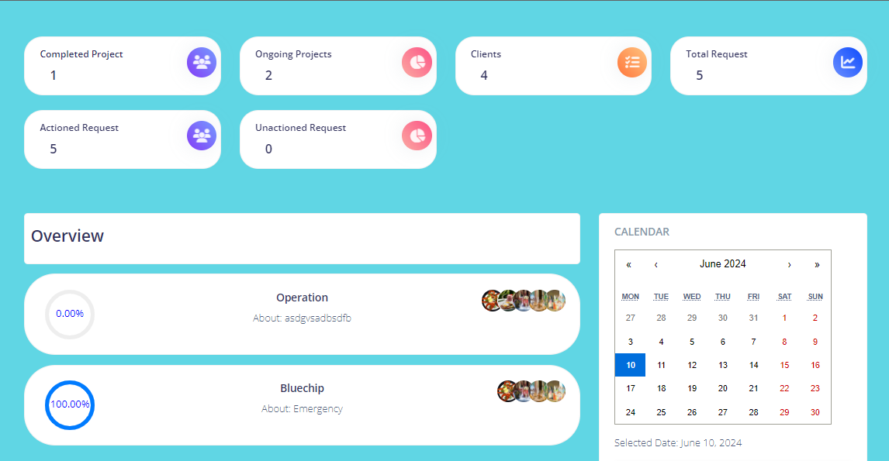

**4.1 General Manager Dashboard**

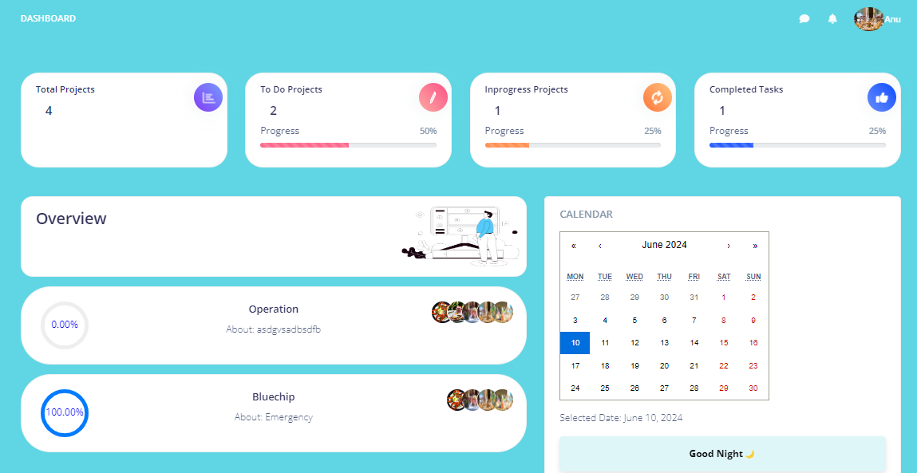

**4.2 Project Manager Dashboard**

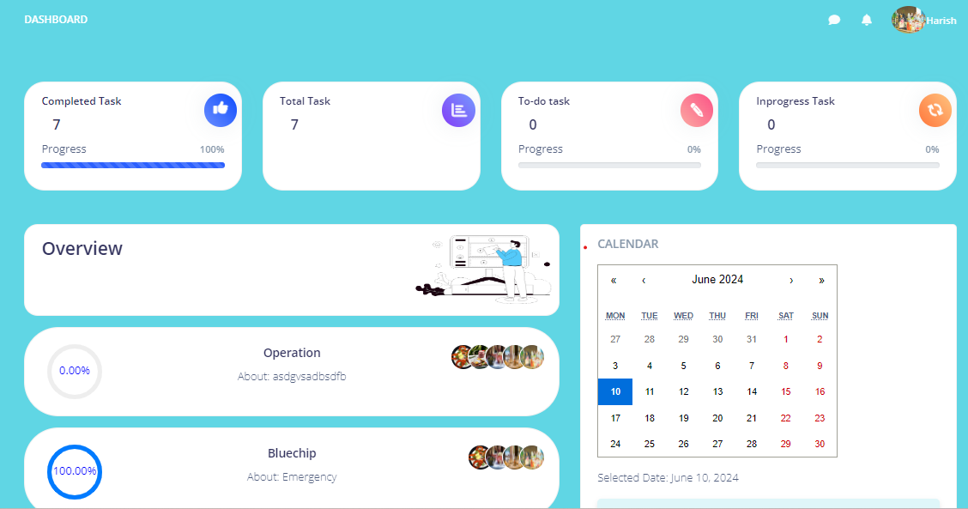

**4.3 Site Manager Dashboard**

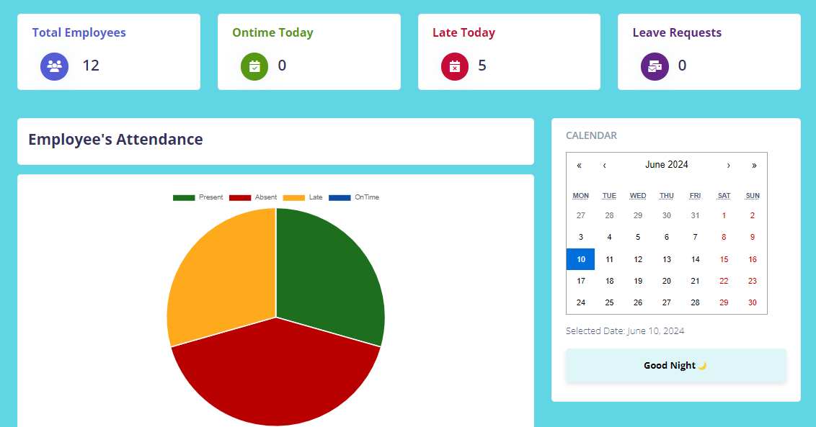

**4.4 HR dashboard**

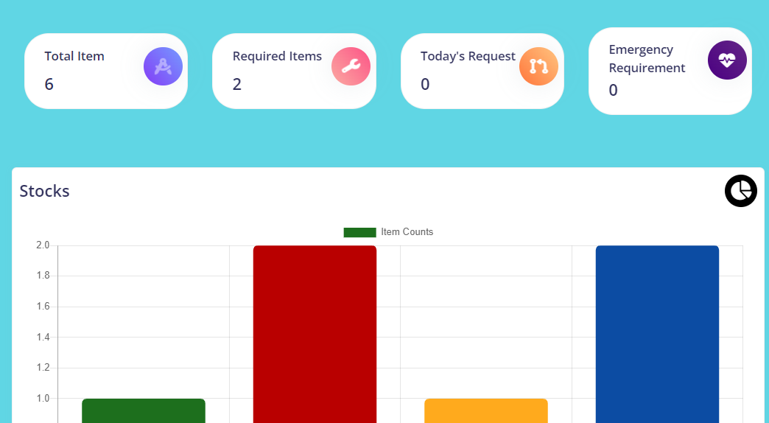

**4.5 Store Management**



**4.6 Client Management Dashboard**

**Navigation**

AECP boasts a user-friendly navigation system, making it effortless to move between different modules, features, and functionalities. A clean and logical menu structure ensures that users can quickly find what they need. The three modules navigation bar is shown below:

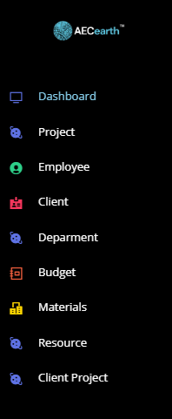 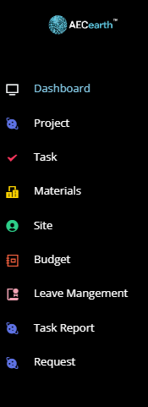 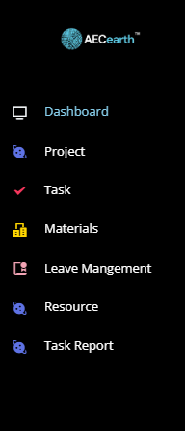

**4.7** General Manager Navigation **4.8** Project Manager Navigation **4.9** Site Manager Navigation

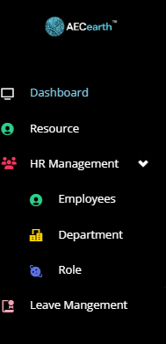 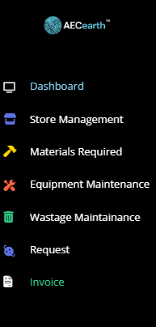 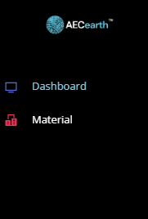

**5.0**  HR Navigation **5.1** Wastage Maintenance Navigation **5.2** Client management Navigation

**Customization**

We understand that every Industry has unique needs, and AECP offers a range of customization options to cater to various requirements. Our customization features empower administrators to tailor the UI to align with the specific workflows and branding of your company, ensuring a personalized experience. Please note that the extent of customization may vary based on your chosen pricing tier or plan. Our flexible pricing structure allows you to select the level of customization that best suits your organization's needs and budget, providing a scalable solution for businesses of all sizes. Explore our pricing options to discover the level of customization that fits your requirements while staying within your budgetary constraints.

**Responsive Design**

AECP's UI is designed to be responsive, adapting seamlessly to various screen sizes and devices. Whether you're accessing AECP on a desktop or smartphone, the experience remains consistent and functional.

**User Profiles**

Each user, from employees to administrators, has their own profile page where they can manage personal information, preferences, and settings. This ensures a personalized experience tailored to individual needs. The user profile is shown below:

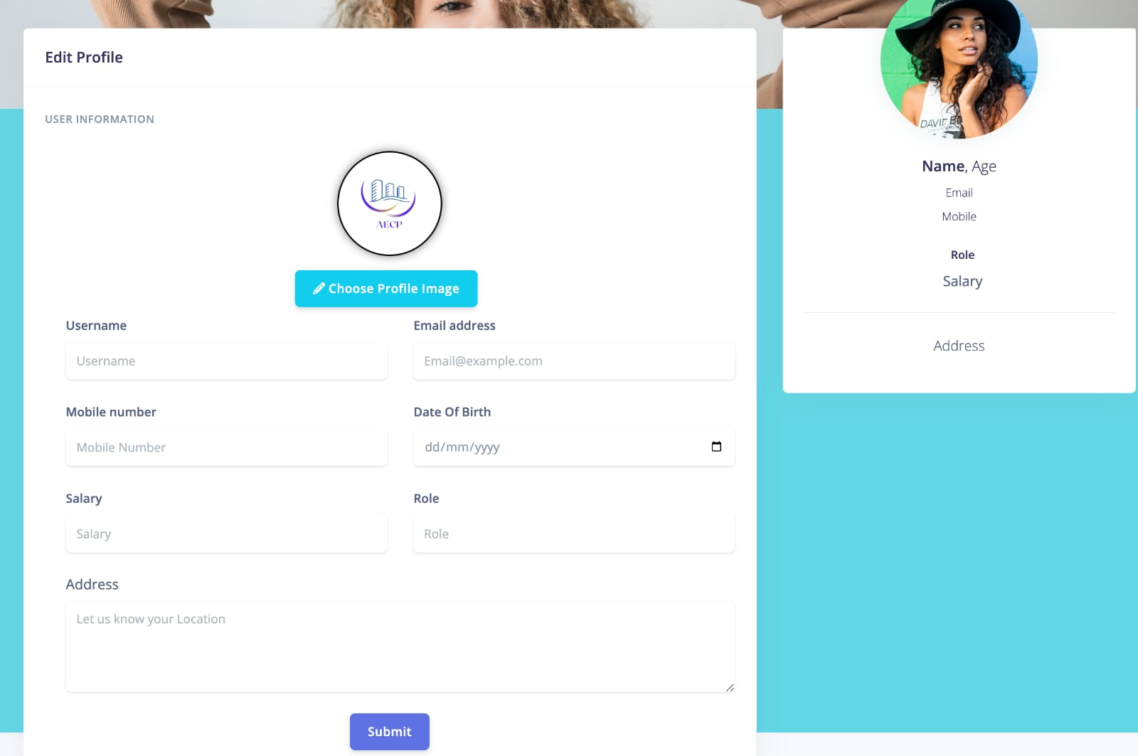

4.7 Profile Settings

**Real-Time Updates**

The UI is designed to provide real-time updates, and notifications, ensuring that users stay informed about critical events, project updates, task assignment and important communications.

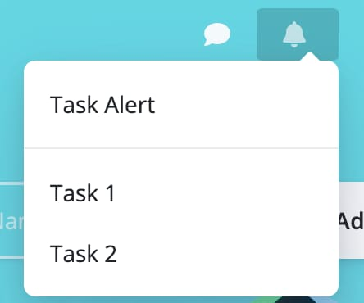

4.8 Notifications

**5. System Architecture**

In this section, we delve into the underlying technology stack, databases, and integrations that power AECP's robust functionality.

**5.1. Technology Stack**

AECP is built on a modern and versatile technology stack that ensures scalability, security, and optimal performance. Our technology stack includes:

**Frontend**

AECP's user-friendly frontend is developed using industry-leading technologies such as React js and Material UI. This allows for a responsive and intuitive user interface.

**Backend**

AECP's backend is driven by a PHP, the robust technology known for their efficiency in building scalable network applications. We harness the power of PHP due to its remarkable speed and remarkable flexibility, especially when managing concurrent connections. This technology stack forms the backbone of AECP, ensuring smooth operations and rapid response times for users across the platform.

**Server Infrastructure**

AECP is hosted on cloud infrastructure, ensuring high availability, security, and scalability. We rely on Amazon Web Services (AWS) to deliver a reliable and performant service.

**Authentication and Security**

At AECP, we prioritize the security of user data. Our approach to user authentication involves the use of MD5 encryption, a widely recognized method for enhancing data security. In addition to MD5 encryption, we implement robust security measures to ensure the confidentiality and integrity of your data. Our system is designed to protect user information and maintain the utmost security throughout your interactions with AECP.

**5.2. Databases**

AECP's data management is primarily centred around SQL databases. Our SQL databases serve as the backbone of our data storage solution, efficiently handling both structured and relational data. This strategic choice ensures robust data organization, retrieval, and reporting capabilities, making AECP an ideal platform for meeting your specific data management needs.

**5.3. Integrations**

Seamless integrations enhance AECP's functionality and adaptability to your industry's needs. We offer integrations with a range of platforms and tools, including:

**Email Services**

AECP seamlessly integrates with popular email services, allowing for efficient communication and notifications through email.

**Calendar Services**

AECP seamlessly integrates with calendar services to enhance your scheduling experience. This integration ensures that your schedule is always up to date, displaying important events such as site managers and project managers birthdays and work anniversaries. Additionally, AECP leverages calendar services to prominently feature project due dates, providing valuable reminders as projects approach their end dates. This feature ensures that you and your team stay well-informed and organized, enhancing productivity and efficiency within your industry.

AECP's robust system architecture, technology stack, databases, and integrations are meticulously designed to provide a flexible, secure, and efficient platform for your organization's needs. Whether you need scalability, real-time communication, or custom integrations, AECP's architecture is built to adapt and perform.

**6. Security Measures**

Security is paramount in AECP, and we have implemented comprehensive measures to safeguard your data and ensure secure user access.

**6.1. Data Encryption**

Data within AECP is protected using state-of-the-art encryption techniques, including industry-standard protocols and algorithms. We employ robust encryption to secure data both in transit and at rest. This ensures that your sensitive information remains confidential and secure, mitigating the risk of unauthorized access or data breaches.

**6.2. Authentication**

AECP employs stringent authentication mechanisms to verify the identity of users. We implement strong password policies to ensure that only authorized individuals gain access to the platform. Our authentication methods, including MD5 encryption, provide an additional layer of security, further protecting user accounts.

**6.3. Authorization**

Authorization in AECP is carefully managed to grant appropriate access rights to users based on their roles and responsibilities. We implement role-based access control (RBAC) to ensure that users can only access the functionalities and data relevant to their roles within the organization. This fine-grained authorization approach enhances security and data privacy, reducing the risk of data exposure.

**7. Roadmap**

At AECP, we are dedicated to continuously improving our product to meet the evolving needs of our users. Our roadmap outlines our planned updates, enhancements, new features, and estimated release dates.

**7.1. Planned Updates**

Our commitment to excellence means we regularly release updates to enhance the functionality, security, and performance of AECP. These updates include bug fixes, optimizations, and other improvements. Our goal is to ensure that you always have the best experience when using our product.

**7.2. Enhancements**

In addition to routine updates, we are continuously working on enhancing existing features to make them even more powerful and user-friendly. These enhancements are driven by user feedback and our dedication to delivering top-notch performance.

**7.3. New Features**

We're excited to introduce the following upcoming features:

**1. 2D to 3D Conversion**

Transform your 2D architectural models into immersive 3D views. Enhance project visualization by pinning comments directly onto specific areas within the 3D model. This feature allows for real-time collaboration, making it easier to identify issues, provide feedback, and optimize designs for maximum efficiency. Keep track of project progress and streamline communication with these advanced visualization and annotation tools.

**7.4. Estimated Release Dates**

While we aim to release updates, enhancements, and new features as soon as they are ready, we understand the importance of transparency. Therefore, we provide estimated release dates for upcoming changes in our roadmap. Please note that these dates are subject to change based on development progress and testing.

Our roadmap is a testament to our commitment to delivering a product that grows alongside your Industry’s needs. We value your input and encourage you to share your suggestions and feedback to help shape the future of AECP. Together, we'll continue to make AECP an indispensable tool for your organization. Stay tuned for exciting updates ahead!

**8. Installation and Compatibility**

AECP is a web-based application, which means there's no need for installation on individual devices. Our platform is accessible directly from your web browser, making it easy for users to get started without any complex setup processes. Below, we outline the system requirements and platform compatibility to ensure you have a seamless experience with AECP.

**8.1. System Requirements**

Since AECP is web-based, it operates independently of your device's operating system. To access AECP, all you need is a device with the following:

**Web Browser**

AECP is compatible with modern web browsers such as Google Chrome, Microsoft Edge, Brave and more. Ensure you have the latest version of your preferred browser for the best experience.

**Internet Connection**

AECP requires an internet connection to access its features and data. A stable and reasonably fast internet connection is recommended for optimal performance.

**8.2. Platform Compatibility**

AECP is designed to be compatible with a wide range of platforms and devices. Whether you're using a Windows PC, Mac, Linux machine, or a mobile device, you can access AECP without any issues. Our responsive design ensures that the user interface adapts to various screen sizes, making it accessible on desktops, laptops, and smartphones.

**8.3. Installation Instructions**

To start using AECP, simply follow these straightforward steps:

**1. Open Your Web Browser**

Launch your preferred web browser.

**2. Visit AECP's Website**

Type in the URL for AECP’s web application. If you have a custom URL provided by your organization, use that.

**3. Log in or Sign Up**

If you're a registered user, log in with your credentials. New users can sign up for an account.

**4. Start Exploring**

Once logged in, you can start exploring AECP's features and functionalities.

Remember that AECP is accessible anytime, anywhere, as long as you have an internet connection and a compatible web browser. There's no need to worry about software installations or updates, as we handle all maintenance and upgrades on our servers.

With AECP's easy accessibility, you can efficiently manage your Industries tasks, projects, and communication without the hassle of traditional software installations.

**9. Getting Started**

Welcome to AECP! We're excited to help you streamline your organization's management and communication processes. This section provides step-by-step instructions to ensure a smooth onboarding experience.

**9.1. Step-by-Step Instructions**

To help you get started quickly, we've prepared a simple step-by-step guide that covers the essentials:

1. **Accessing AECP:** Open your preferred web browser and navigate to AECP's web application URL.
2. **Account Setup:** If you're a new user, sign up for an account by providing your details and organization information.
3. **Login:** For existing users, log in with your credentials.
4. **Dashboard Tour:** After logging in, we invite you to embark on a guided tour of our dashboard. As you hover over each option, informative tooltips will appear. This hands-on approach ensures that you'll quickly become comfortable navigating and utilizing all the available modules and features.
5. **Personalize Your Profile:** Click on your profile icon to access your settings. Here, you can update your profile information, and password.
6. **Creating Projects:** If you're a project manager, start by creating a project and assigning tasks to Site Managers. Use the project module to track progress.
7. **Task Assignment:** Assign tasks to Site Managers using the task management module. Set deadlines and priorities to keep everyone on track.
8. **Leave Management:** If you're an HR manager, use the leave management module to handle employee leave requests and maintain leave records.
9. **Timesheet:** For accurate time tracking, employees can use the timesheet module to record hours worked on tasks.
10. **Notifications:** Stay informed with real-time notifications like chat notifications and task notifications.
11. **Live Location Tracking:** Keep a watchful eye on your team's real-time geographical locations. This feature is invaluable for efficient resource allocation, ensuring employee safety, and making informed decisions.
12. **Calendar Management:** AECP's calendar tool goes beyond scheduling. It displays employee birthdays, work anniversaries, and project due dates, providing a holistic view of your organizational schedule.
13. **And More:** AECP continually evolves with user feedback and industry trends. Stay tuned for upcoming features, such as live application tracking, automated payslip generation, face recognition, and an auto-generated project roadmap. These enhancements will further empower your organization and simplify your daily operations.

**10. Contact Information**

For any inquiries, assistance, or feedback related to AECP, please feel free to contact us. We are here to provide you with the support and information you need to make the most of our platform.

**10.1. General Inquiries**

For general inquiries, partnerships, or any other non-technical matters, you can contact us via email at ‘info@mineit.tech’. We welcome your feedback, suggestions, and collaboration opportunities.

We value your input and look forward to assisting you with any inquiries or requests you may have. Your satisfaction is our priority.

**11. Legal Information**

We take legal matters seriously at AECP and aim to ensure transparency with all relevant regulations.

**11.1. Disclaimers**

While we strive to provide accurate and up-to-date information, AECP disclaims any warranties or representations, expressed or implied, regarding the accuracy, completeness, or suitability of the information on our platform. Users are responsible for verifying information and using AECP at their discretion.

**11.2. Terms of Service**

To understand the terms and conditions governing the use of AECP, please review our comprehensive Terms of Service. These terms outline user responsibilities, usage policies, and other important details regarding your interaction with our platform.

**11.3. Privacy Policy**

Protecting your privacy is a top priority for us. Our Privacy Policy explains how we collect, use, and protect your personal information when you use AECP. We encourage you to review this policy to understand how your data is handled.

**12. Version History**

**12.1. Version 1.0**

**Initial Release**

The first version of our product, AECP, is now available! This marks the beginning of a powerful journey to streamline your organization's processes. In this initial release, you can expect:

1. Key features and functionalities available in this release.
2. Benefits in this version.

**1. Key features and functionalities available in this release**

* Site and Project Manager Attendance System & Automatic Logout
* Project Management
* Task Management
* Site and Project Manager Leave Management
* Timesheet
* Notification System & Email System
* Monthly Report Generator
* Profile Management
* Daily Calendar Management
* Stock Management
* Waste Management
* Maintenance of Items
* Request Management
* Client Management
* Project Progress Tracking
* Macro Management
* Procurement Management

**2. Benefits in this version**

* Streamlined Site and Project manager Management
* Efficient Project Coordination
* Enhanced Task Assignment
* Effective Leave Management
* Accurate Time Tracking
* Effective Communication
* Comprehensive Reporting
* User Profile Control
* Personalized Daily Calendar
* Improved Inventory Control
* Waste Reduction
* Asset Maintenance
* Simplified Request Handling
* Enhanced Client Relations
* Real-Time Project Monitoring
* Holistic Oversight
* Optimized Procurement Processes
  1. **. Key Changes**

**Initial Release**

AECP was introduced to the market, offering a comprehensive suite of features for efficient employee management, project coordination, communication, and productivity enhancement.

**User Authentication**

Robust user authentication mechanisms were implemented to ensure secure access to the platform, including the utilization of MD5 encryption for data security.

**Real-time Features**

AECP introduced real-time features within its platform, enabling instant messaging, notifications, and collaborative tools with minimal latency, all achieved without using external WebSockets.

**Database Integration**

The system seamlessly integrates SQL databases to efficiently handle structured data and relational data requirements

**Advanced Features**

The release included advanced features like calendar management, and an automatic logout feature for enhanced security.

**Enhanced Reporting**

AECP introduced a robust monthly report generator, providing comprehensive insights into employee performance, project progress, and productivity.

**Notification Centre**

A notification system and email integration were added to enhance communication and keep users informed about their tasks.

**13. Conclusion**

**13.1. Summary of Key Points**

In summary, AECP is a versatile web-based application designed to streamline various aspects of organizational management. With a wide range of features, including site managers attendance tracking, project management, task management, and more, it offers comprehensive solutions to enhance productivity and efficiency within your organization.

**13.2. Value and Benefits**

AECP brings significant value to your organization by providing a centralized platform for efficient HR management, project coordination, and communication. Its user-friendly interface, customization options, and real-time features empower your team to collaborate effectively, optimize resource allocation, and make data-driven decisions. By automating key processes, AECP enhances productivity, reduces administrative overhead, and fosters a more connected and informed workplace.

Discover how AECP can transform your organization's workforce management, communication, and productivity – start your journey today.